 | Blue Door Nursery late Summer newsletter. September 2019 |  | 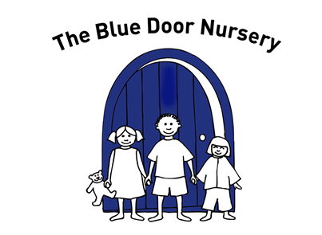
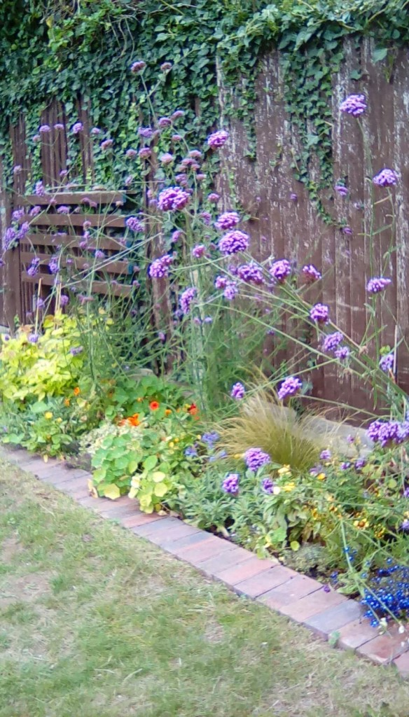  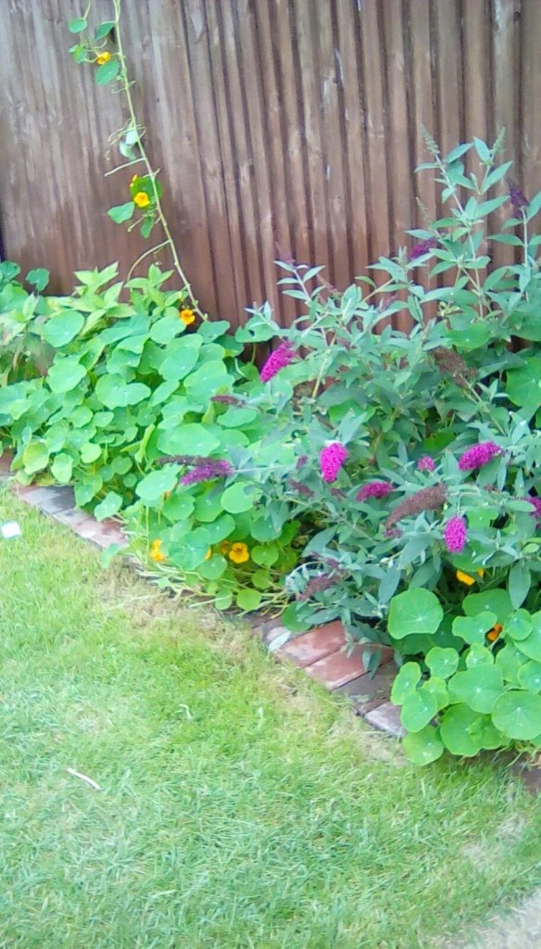  As we move towards the Autumn months we will begin to see coughs and colds spreading through nursery. We do all we can to keep the staff and children healthy – please make sure you play your part too! This means:  Arranging for someone else to collect your child if you are suffering from a heavy cold.  Using the hand sanitiser at the entrance door to protect our children from germs when you come in.  Not sending your child to nursery if they are unwell. We do not administer Calpol if children are poorly – if they need Calpol, they need to be at home.  Keeping your child at home if they have had a bout of sickness or diarrhoea. We ask that they are kept at home for 48 hours after the last ‘episode’. Here is a link to our website where you will find our Sickness and illness policy which goes into detail about exclusion periods for illnesses. https://www.bluedoornursery.co.uk/important-information/ |  | As we told you in our last newsletter we were delighted to receive a generous donation from Paradise Park to help us develop our planting spaces in the garden. As you can see from the photos the new flower beds look gorgeous! The children have enjoyed talking to Katie (one of our parents) about the planting she is doing and have been very helpful to Laurence (our caretaker) keeping on top of the watering!! If you want to help with our garden we would be delighted to hear from you.  We continue to enjoy the garden in all weathers – please make sure your child has appropriate clothing! For the very youngest children, an ‘all in one’ suit can be very helpful as they do like to get ‘in amongst’ the grass and the play areas. Everyone else needs wellies and a coat.  Remember too that we still need sun cream on the sunshiny days!  Over the next week or so staff are going to be (re) introducing themselves to you on Tapestry. Some staff have changed groups and some children have moved rooms – we thought it would be nice to reintroduce ourselves to everyone! On Tapestry, we love to see what you have been up to at home – it really helps us understand more about your child and they love showing us the pictures you send. Please make sure you only add observations and comments to the Tapestry journal for your own child – not the ‘group’ children [Kittens 2019/20, Cubs 2019/20, Lions 2019/20] - we use these journals to send you news, information and photos of the children more generally. | Staffing update…  We have said goodbye to Megan over the summer who has joined American Express Travel in Brighton and has made a career change. We will be saying goodbye to Becky during September who has now finished her L2 apprenticeship and is moving to a nursery in Brighton to continue her training at L3.  Many of you will have met Zoe over the summer who is working in the Cubs’ team. Zoe was part of the management team at Hopscotch nursery and has brought some very valuable skills to Blue Door. She is already a firm favourite with many children and has become part of the Blue Door family very quickly. We have recently welcomed Isobel from Busy Bees nursery in Brighton and she has made an excellent start in the Kittens’ room. Isobel is L3 qualified and has several years of experience. We are excited to welcome her to the Blue Door team.  We are currently recruiting for a junior apprentice and a qualified staff member to take some part time hours at nursery.  Reminders  - Please be considerate to our neighbours when you are dropping off or picking up your child. Please don’t park over their driveways- it’s not fair. Please drive round the corner to find a safe space to park – we have seen parents ‘double-parking’ to ‘save a couple of minutes’ – we need to keep all the children safe and by double parking you are putting children in danger.  - If your child’s routine changes please let us know in writing (by email, via Tapestry or a good old fashioned note). This helps us ensure that messages are passed promptly to staff with the correct details  DIARY DATES  28th October – 1st November is ½ term. Funded children return on 4th November  Wednesday 20th November 6.30-8.30pm Parents’ evening and Funding information.  Friday 20th December is last day for funded children. They return to nursery on Monday 6th January.  Tuesday 24th December 1pm Nursery closes for Christmas, reopening at 7.30am on Thursday 2nd January  Friday 3rd April 1pm Nursery closing for staff training afternoon

new session types….
The new sessions we introduced in September have proved extremely popular and many families have found them helpful and have thanked us for our flexibility. We will continue until the end of September with allowing parents to change their sessions without notice. From October, we will need a month’s notice to make changes as per our contract. If you are thinking of adding sessions during the 2019/2020 nursery year please let us know now as we are already getting very full on some days. Similarly, if you have friends who are thinking of using the nursery before September 2020 it would be sensible for them to make their bookings now so that we are able to facilitate their needs!
For advice regarding tax free childcare, applications for additional support and to apply for the 30 hours funding:
www.eastsussex.gov.uk/childrenandfamilies/childcare/free-childcare/

